**E-commerce Application on IBM cloud Foundry**

**TEAM MEMBER:**

11142104077:paramaguru.A.S

**Phase 2: Problem Definition and Design Thinking**

Build an artisanal e-commerce platform using IBM Cloud Foundry. Connect Skilled artisans with the global audience. Showcase handmade products , from exquisite jewellery to artistic home decor. Implement secure shopping carts, Smooth payment gateways, and an intuitive checkout process. Nuture creativity and support small business throw an artisan’s dream marketplace!

**Problem Definition:**

Building an artisanal e-commerce platform using cloud foundry will help the skilled artisans connect with the global audience. The handmade products and handcrafts are not well-known by many people and the job of the artisans are vanishing day by day as people are unaware of the handmade products.

Inorder to solve the problem,the handcraft products must be marketed for which a e-commerce platform must be created to showcase the products so that people can easily access the products.The objective is to leverage IBM cloud's infrastructure and services to create a secure,scalable and user-friendly online marketplace.

a web-based portal designed keeping in mind the dedication and hardwork of individual artisans and craftsmen. Aim is to incorporate modern technology to provide artisans with a platform to showcase their skills of crafts and cater to a wider range of audience. This approach reduces the cost of acquiring a middle-man and also provides an opportunity for a greater profit margin for the sellers. Sellers can directly register on the portal and showcase their skills to the world

**Design Thinking:**

Building an artisanal e-commerce platform on IBM Cloud Foundry involves several steps. Below is a high-level outline of the process. Please note that this is a simplified overview, and you might need to adapt it based on your specific requirements and the tools available on IBM Cloud Foundry.

Platform design:

To design the platform layout with sections for product categories, individual project pages, shopping cart, checkout and payment,front end is being used and back end is used to ensure the accessibility.

**Product Showcase**:

Mongo database is used to store product information such as images, description, prices, and categories which is used to create the ecommerce.

**User Authentication:**

User registeration and authentication features are implemented . Once this has been confirmed,authorization is then used to enable artisans and customers to access the platform.

**Shopping cart and Checkout:** Back end isresponsible for storing and organising data, and ensuring everything on the client-side actually worksto develop the shopping cart functionality and smooth checkout process.

**Payment Integration:** A payment processor is chosen and security features are implemented ,that is integrated to facilitate transactions.

**User Experience:** Focus on providing an intuitive and visually appealing user experience for both artisans and customers ,products which are usable, credible, valuable, accessible and desirable are much more likely to succeed

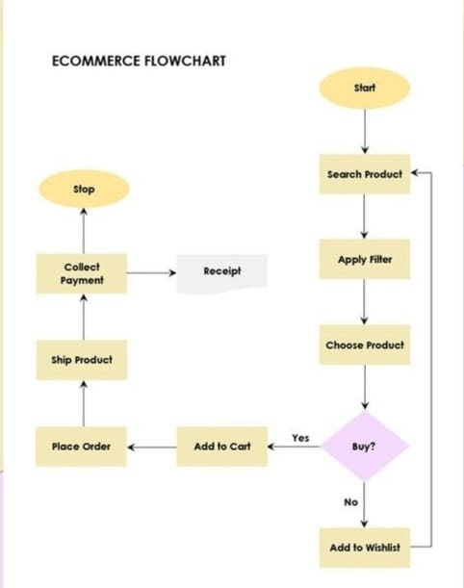

TECHNOLOGY

MERN Stack

MERN stack is an acronym for four popular technologies - MongoDB, Express, React, and Node. MERN stack is widely used for developing web applications and provides a robust and scalable environment for building web applications.

MongoDB is a NoSQL database that is designed to store data in JSON-like documents. MongoDB is widely used for building scalable and flexible databases, making it ideal for web applications.

Express is a popular web application framework for Node.js that provides a robust set of features for building web applications. Express simplifies the development of web applications by providing a variety of tools and features, such as middleware, routing, and templating engines.

React is a JavaScript library for building user interfaces. React provides a component-based architecture that makes it easy to build reusable UI components, which can be used across different parts of the application.

NodeJs is a JavaScript runtime built on the Chrome V8 JavaScript engine.. NodeJs provides a variety of features that simplify the development of web applications, such as a built-in HTTP server and a module system for managing dependencies.

Advantages of MERN

1) Full-stack javascript

2) Fast development

3) Scalability

4) Community support

SYSTEM ARCHITECTURE

The System Architecture is divided into 3 sections: Backend, Database and Frontend.

1) Backend: For backend part we have used NodeJS a JavaScript runtime environment with Express framework which provide APIs.

2) Database: For the database we have used the MongoDB store the user details, product details and order details. MongoDB is a popular NoSQL document-oriented database that stores data in a flexible, JSON-like format called BSON.

3) Frontend : For the Frontend we have used ReactJS. For designing part html, CSS, JavaScript are used.

a) HTML: HTML stands for Hyper Text Markup Language. It is used to create webpages.Html has elements which tells the browser how to display the content.

b) CSS: CSS is the language we use to style an HTML document.CSS describes how the html elements should be displayed

c) JavaScript: Is used to program the behaviour of web pages. For the database we have used the MongoDB store the user details, product details and order details .

SAMPLE CODE FOR AN WEBSITE CREATION

HTML

<!DOCTYPE html>

<html>

<head>

<title>Handmade Products E-commerce Website</title>

<meta charset="UTF-8">

<meta name="viewport" content="width=device-width, initial-scale=1.0">

<link rel="stylesheet" type="text/css" href="nmm.css">

</head>

<body>

<header>

<h1>Handmade Products</h1>

<nav>

<ul>

<li><a href="#">Home</a></li>

<li><a href="#">Shop</a></li>

<li><a href="#">About Us</a></li>

<li><a href="#">Contact Us</a></li>

</ul>

</nav>

</header>

<main>

<section>

<h2>Featured Products</h2>

<div class="product">

<img src="product1.jpg" >

<h3>Product 1</h3>

<p>Description of Product 1</p>

<button>Add to Cart</button>

</div>

<div class="product">

<img src="product2.avif" alt="Product 2">

<h3>Product 2</h3>

<p>Description of Product 2</p>

<button>Add to Cart</button>

</div>

<div class="product">

<img src="demo products.jpg" alt="Product 3">

<h3>Product 3</h3>

<p>Description of Product 3</p>

<button>Add to Cart</button>

</div>

</section>

<section>

<h2>Latest Products</h2>

<div class="product">

<img src="product4.jpg" alt="Product 4">

<h3>Product 4</h3>

<p>Description of Product 4</p>

<button>Add to Cart</button>

</div>

<div class="product">

<img src="p.jpeg" alt="Product 5">

<h3>Product 5</h3>

<p>Description of Product 5</p>

<button>Add to Cart</button>

</div>

<div class="product">

<img src="product6.jpg" alt="Product 6">

<h3>Product 6</h3>

<p>Description of Product 6</p>

<button>Add to Cart</button>

</div>

</section>

</main>

<footer>

<p>&copy; 2021 Handmade Products. All rights reserved.</p>

</footer>

</body>

</html>

CSS

* {

box-sizing: border-box;

margin: 0;

padding: 0;

}

body {

font-family: Arial, sans-serif;

}

header {

background-color: #333;

color: #fff;

display: flex;

flex-direction: column;

align-items: center;

padding: 20px;

}

nav ul {

display: flex;

list-style: none;

margin-top: 20px;

}

nav ul li {

margin: 0 10px;

}

nav ul li a {

color: #fff;

text-decoration: none;

}

main {

display: flex;

flex-wrap: wrap;

justify-content: space-around;

padding: 20px;

}

section {

flex-basis: 45%;

margin-bottom: 20px;

}

section h2 {

margin-bottom: 10px;

}

.product {

background-color: #f2f2f2;

border: 1px solid #ddd;

border-radius: 5px;

box-shadow: 0 0 5px #ddd;

padding: 10px;

text-align: center;

}

.product img {

max-width: 100%;

}

.product h3 {

margin-top: 10px;

}

.product p {

margin-top: 10px;

}

.product button {

background-color: #333;

border: none;

border-radius: 5px;

color: #fff;

cursor: pointer;

margin-top: 10px;

padding: 10px;

transition: background-color 0.3s ease;

}

.product button:hover {

background-color: #555;

}

footer {

background-color: #333;

color: #fff;

padding: 20px;

text-align: center;

}

SAMPLE OUTPUT

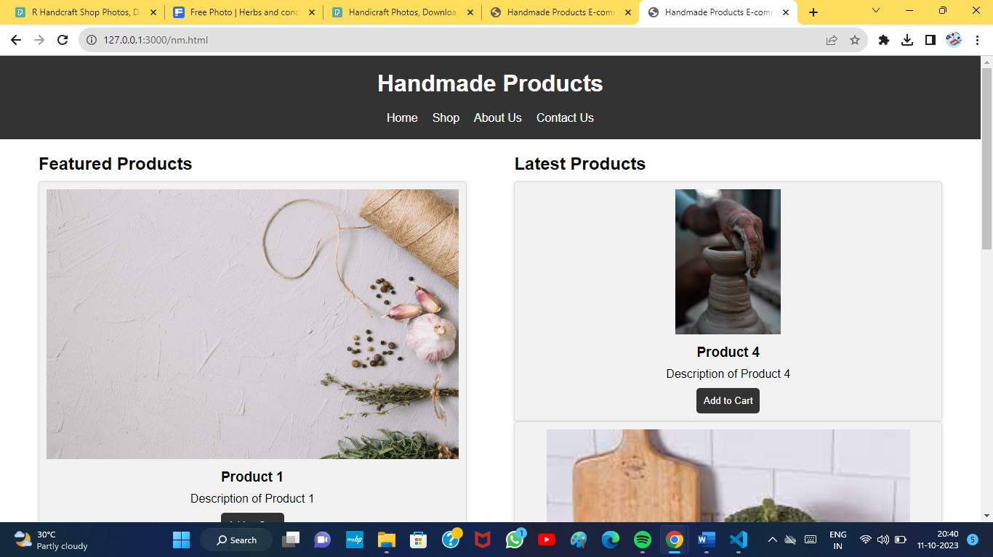

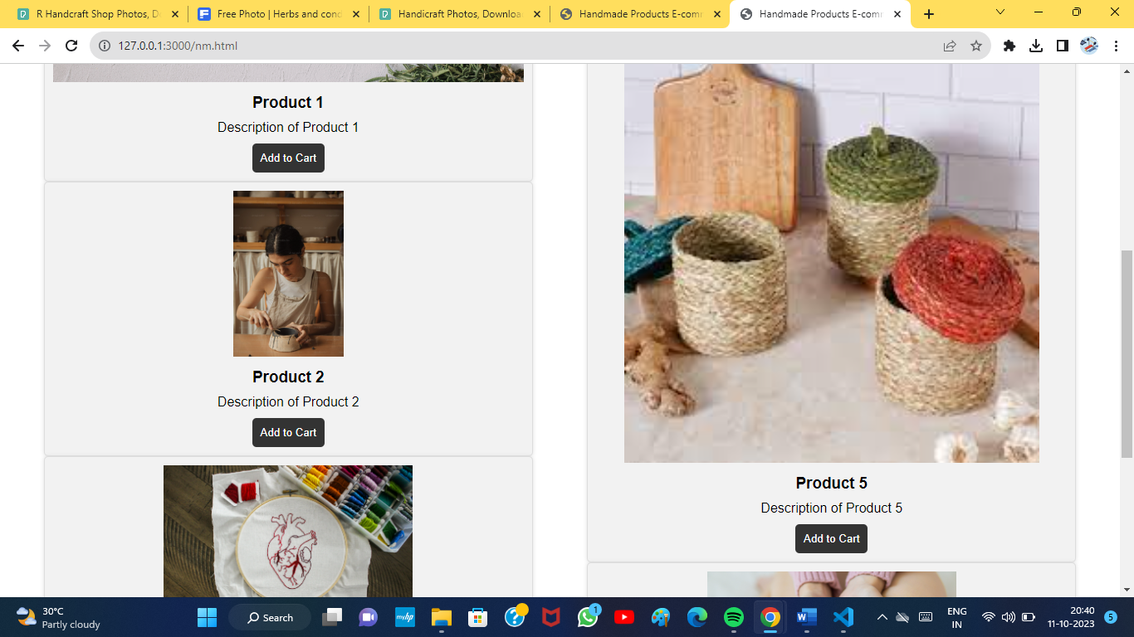

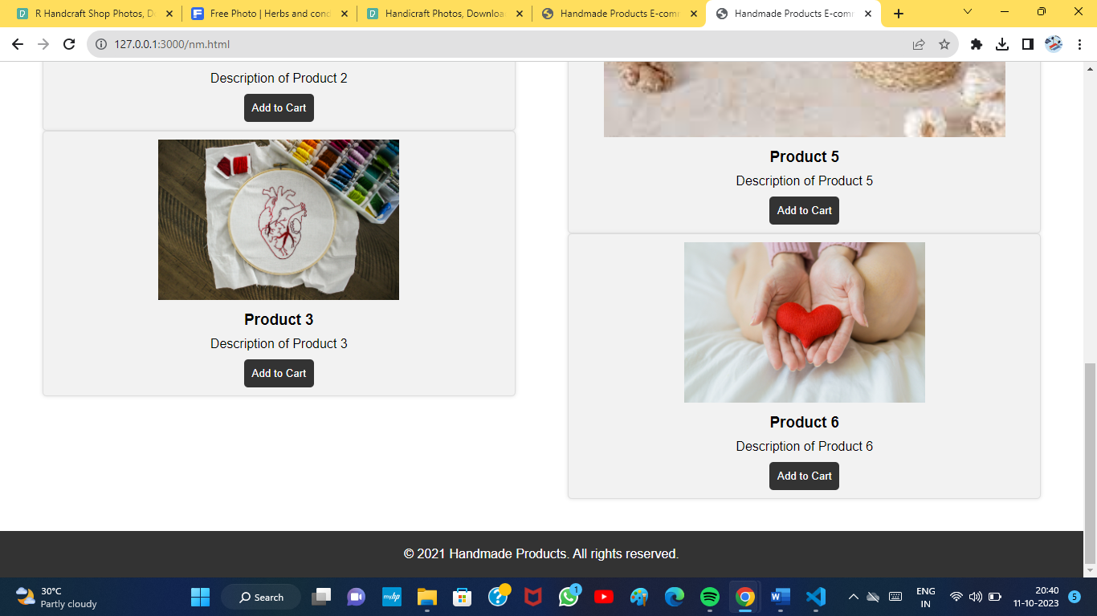

CONCLUSION

By building an eCommerce website for artists using the MERN stack can be a great option for those looking to create a high-quality, scalable, and efficient platform. Ecommerce is one of the largest factors of economy growth, it connects businesses with customers in fast, easy and secure way. This solution can help artisans to reach a wider audience and increase their sales, while also providing customers with a convenient and secure platform to purchase handmade products. The MERN stack provides a comprehensive solution for building both the front-end and back-end of an eCommerce website.